Gift Aid Declaration
Single Donation
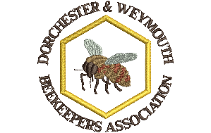
Dorchester & Weymouth BKA
Charity Reference N^{o.}: EW27558
Boost your donation by 25p of Gift Aid for every £1 you donate
Gift Aid is reclaimed by the Association from the tax you pay for the current tax year. Your address is needed to identify you as a current UK taxpayer.

In order to Gift Aid your donation please tick the box below:
• I want to Gift Aid my membership subscription to:

Name of Organisation: Dorchester & Weymouth Beekeepers Association.

I am a UK taxpayer and understand that if I pay less Income Tax and/or Capital Gains Tax than the amount of Gift Aid claimed on all my donations in that tax year it is my responsibility to pay any difference.

My Details
Title __________ First name or initial(s) ______________________________
Surname ______________________________________________________
Full Home Address ______________________________________________
______________________________________________________________
______________________________________________________________
Postcode __________________ Email _______________________________
Date ____________________________
Please notify the Association if you:
• want to cancel this declaration
• change your name or home address
• no longer pay sufficient tax on your income and/or capital gains
If you pay Income Tax at the higher or additional rate and want to receive the additional tax relief due to you, you must include all your Gift Aid donations on your Self-Assessment tax return or ask HM Revenue and Customs to adjust your tax code.
For further information contact the D&W BKA Treasurer, Ben Benjamin on 01305 268432 or at chrisbenbenjamin@gmail.com

Please return your completed form to Ben Benjamin at: chrisbenbenjamin@gmail.com or post to: R. Benjamin, 6 Princes Mews East, Princes Street, Dorchester, DT1 1UL

